
RIVER CITY KIDS 2025 RACE SERIES
The River City Runners and Walkers Club is excited to announce the 2025 River City Kids race series! The series is FREE to all kids ages 1-11. All participants will receive a FREE race tshirt and goody bag. Award ribbons and popsicles will be given to all finishers. Participants who complete at least 6 of 11 races will receive a personalized medal and those who complete at least 7 of the races will receive a River City Kids Hoody. Awards will be given at the end of the season pool party.

Signing up is easy!
*Pre-register through runsignup on the River City Kids Facebook Page or on the club website: rivercityrunnersandwalkers.com.
*Race day sign up is available: please show up at least 30 minutes prior to race time listed in calendar below to register race day.
Run distances are based on age as follows:
3& under 50 meters
4&5 100 meters
6&7 200 meters
8&9 400 meters
10&11 400 meters

*TO MAKE SURE THAT YOUR CHILD RECEIVES CREDIT FOR EACH RACE, PLEASE CHECK IN AT THE REGISTRATION TABLE UPON ARRIVAL.

We can’t wait for the fun events planned this season! Please visit River City Kids Facebook page for news and updates as well as photos from the races.
Contact: Amy Eddy 304-488-1656 amyeddy222@hotmail.com

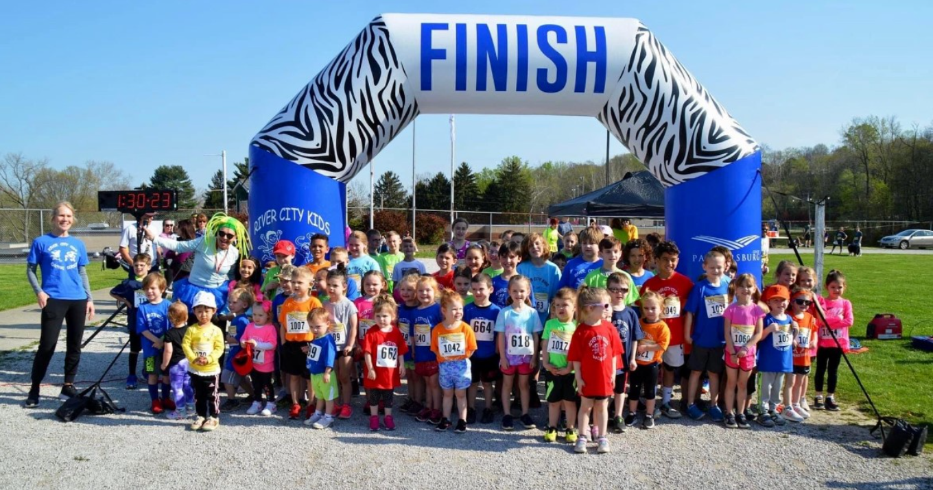
2025 Race Calendar
Date | Race | Location | Kids race start time
4/5/25 | *Premier Dental Race | Jackson Middle School Track, Vienna, WV | 10am
4/19/25 | Beverly Bunny Hop | Fort Frye High School, Beverly, Ohio | 9:30am
5/3/25 | Slip Slap Slop | Parkersburg City Park | 9:30am
5/10/25 | Mother's Day 5K | Belpre Civitan Park | 10am
5/24/25 | Sternwheel 5K | Muskingum Park, Marietta, Ohio | 9am
6/14/25 | *Dads Day Race | Point Park, Parkersburg | 10am
6/21/25 | Chick Fil-A | Parkersburg High School Track | 9:30am
7/12/25 | *Kids Summer Bash | Parkersburg High School front lawn | 10am
7/26/25 | *Henderson Hall  Hoedown | Henderson Hall,  River Road, Williamstown WV | 10am
8/2/25 | RRHC Stepping on Hunger 5K | Harrisville, WV | 9am
8/17/25 | *River City Kids Classic | Parkersburg High School Track | 1pm
* Denotes free standing kids race

